Aggregate and Scalar Functions

**Functions** are methods used to perform data operations. SQL has many in-built functions used to perform string concatenations, mathematical calculations etc.

SQL functions are categorized into the following two categories:

1. **Aggregate Functions**
2. **Scalar Functions**

What's the main difference between Scalar & Aggregate Functions?

**Aggregate** and **Scalar functions** both return a single value but **Scalar functions** operate based on a single input value argument while **Aggregate functions** operate on a single input set of values (a collection or column name).

Aggregate Functions

Aggregate Functions in SQL perform calculations on a group of values and then return a single value. Following are a few of the most commonly used Aggregate Functions:

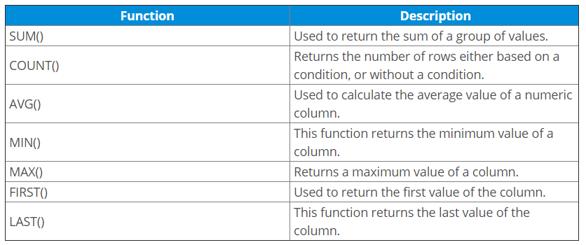

Example:

In order to run some aggregate functions on data, let's populate a dummy database using a realistic data generator called [Mockaroo](https://www.mockaroo.com/" \o "https://www.mockaroo.com/).

1. Create a new Postgres connection on localhost and open an empty SQL editor.
2. Run the following code in your editor:

CREATE TABLE students (

student_id SERIAL PRIMARY KEY,

first_name VARCHAR(50),

last_name VARCHAR(50),

marks INT

);

1. Insert the following data into your table to populate your tables with dummy data:

INSERT INTO students (first_name, last_name, marks) VALUES ('Rubetta', 'Arnault', 71);

INSERT INTO students (first_name, last_name, marks) VALUES ('Pavlov', 'Gedney', 77);

INSERT INTO students (first_name, last_name, marks) VALUES ('Pauline', 'Cruess', 61);

INSERT INTO students (first_name, last_name, marks) VALUES ('Gustav', 'Lambeth', 81);

INSERT INTO students (first_name, last_name, marks) VALUES ('Garey', 'Goulding', 96);

INSERT INTO students (first_name, last_name, marks) VALUES ('Sidonnie', 'Lofthouse', 63);

INSERT INTO students (first_name, last_name, marks) VALUES ('Vicki', 'Mardling', 87);

INSERT INTO students (first_name, last_name, marks) VALUES ('Michal', 'Londsdale', 61);

INSERT INTO students (first_name, last_name, marks) VALUES ('Hephzibah', 'Gealy', 76);

INSERT INTO students (first_name, last_name, marks) VALUES ('Cherrita', 'Theuff', 66);

INSERT INTO students (first_name, last_name, marks) VALUES ('Shandee', 'Dell Casa', 83);

INSERT INTO students (first_name, last_name, marks) VALUES ('Pedro', 'Collister', 95);

INSERT INTO students (first_name, last_name, marks) VALUES ('Adam', 'Petkovic', 68);

INSERT INTO students (first_name, last_name, marks) VALUES ('Margaux', 'Drinkale', 95);

INSERT INTO students (first_name, last_name, marks) VALUES ('Helene', 'Disbrow', 67);

INSERT INTO students (first_name, last_name, marks) VALUES ('Sigismundo', 'Gomery', 93);

INSERT INTO students (first_name, last_name, marks) VALUES ('Tobi', 'Loukes', 79);

INSERT INTO students (first_name, last_name, marks) VALUES ('Lemar', 'Warburton', 78);

INSERT INTO students (first_name, last_name, marks) VALUES ('Dorree', 'Sweedy', 98);

INSERT INTO students (first_name, last_name, marks) VALUES ('Duke', 'Kendrew', 75);

1. We can now run Aggregate functions against this data to return a single value from all of the data stored within a particular column. Run the following AVG() aggregate function to return the average mark from the marks column:

SELECT AVG(marks)

FROM students;

This should return 78.5 as the average grade within the students table.

1. Experiment with other functions such as MAX(), MIN().
2. COUNT() returns the number of rows present in the table based on a particular condition define by the where clause. For example:

SELECT COUNT(student_id)

FROM students

WHERE marks > 75;

Scalar Functions

Scalar Functions are used to return a single value from *user* input. PSQL supports scalar functions that may be included in a SQL statement as a primary expression.

Scalar Fucntions in PSQL can be divided into the following categories:

* **String Functions**
  + LOWER(string): Converts all upper case characters in string to lower case.
  + CONCAT(string1, string2): Returns a string that results from combining string1 and string2.
  + LENGTH(string): Returns the number of characters in string
  + SUBSTRING(string1, start, length) : Returns a character string derived from string1 beginning at the
* **Numeric Functions**
  + ROUND (numeric_exp, integer_exp): Returns numeric_exp rounded to integer_exp places right of the decimal point.
  + MOD (integer_exp1, integer_exp2): Returns the remainder (modulus) of integer_exp1 divided by integer_exp2.
* **Time and Date Functions**
  + CURDATE( ): Returns the current local date in the format 'yyyy-mm-dd'. Uses the local clock time by default.
  + NOW(): Returns the current local date and time as a time stamp value in this format: yyyy-mm-dd hh:mm:ss.mmm
* **Conversion Functions, etc...**

You can find a complete list of PSQL Scalar Functions [here](https://docs.actian.com/psql/psqlv13/index.html#page/sqlref/scalarfunc.htm#ww1138742)

Example:

The following demos will continue to utilize the dummy data that we've built in our current database:

1. Write a query to retrieve the names of all students in lowercase:

SELECT LOWER(first_name)

FROM students;

1. Write a query to extract a substring of a particular record:

SELECT SUBSTRING(first_name,2, 3)

FROM students WHERE first_name = 'Pavlov';

References:

* [PSQL Scalar Functions](https://docs.actian.com/psql/psqlv13/index.html#page/sqlref/scalarfunc.htm)